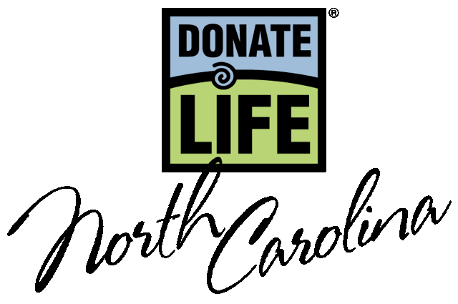
March 2024

Dear Driver Education Student,

Greetings from Donate Life North Carolina!

In your driver education class, you will learn about the vital importance of organ, tissue and eye donation. This information is provided because you will be asked to consider joining the North Carolina Donor Registry at the NCDMV when you apply for your driver’s license.

In North Carolina, you must be 16 years old to register as a donor. However, until you turn 18, your parent or guardian has the final say about donation if something were to happen to you. We encourage you to discuss your donation decision with your family. If your family knows that you want to be a donor, they are more likely to support your decision. If you join the Donor Registry without telling them, it may come as a surprise to them. Your family may be more comfortable supporting your decision to donate if they know you want to save and improve lives by being a donor.

Here are some tips on starting a conversation about organ and tissue donation with your family: • Educate yourself about donation before talking to your family. Having some basic facts in mind will give you the confidence to talk about your feelings and answer any questions raised by others. Refer to the Donate Life NC website at donatelifenc.org.
• Explain why donation feels like the right thing for you. Explain how one person can help save and heal up to 75 lives through donation.
• Share what you’ve learned in your driver education class, especially personal stories of those touched by organ and tissue donation.

Thank you for considering the life-saving decision to join the North Carolina Donor Registry. For more information, visit donatelifenc.org.

Sincerely,

Tiffianna

Tiffianna Elmore
Teen & DMV Outreach Manager
telmore@donatelifenc.org

P.S. Want to get involved? Take a look at our teen resources, honor cord, and scouts’ programs available on our website.

Donate Life

North Carolina

DonateLifeNC.org

Primary Mailing Address
Deanna Kerrigan
Executive Director
Donate Life North Carolina
PO Box 5536
Cary, NC 27512
919-213-1069
dkerrigan@donatelifenc.org

Chairperson
Matthew Kersten, MS, MBA
Director, Transplant Business
Operations
Atrium Health
704-446-4807
Matthew.kersten@atriumhealth.org

Vice Chair
Carrie Simpkins
Atrium Wake Forest Abdominal
Transplant
Medical Center Blvd.
Winston Salem, NC 27157
336-713-5623 (o)
csimpkin@wakehealth.edu

Secretary
Lora Smitherman
HonorBridge
1430 Westbrook Plaza Drive
Winston-Salem, NC 27103
336-774-4450
Lsmitherman@honorbridge.org

Past Chairperson
Lauren Fieldman, MPH, BSN
Duke Transplant Center
Durham, NC 27710
919-668-3049
lauren.fieldman@duke.edu

