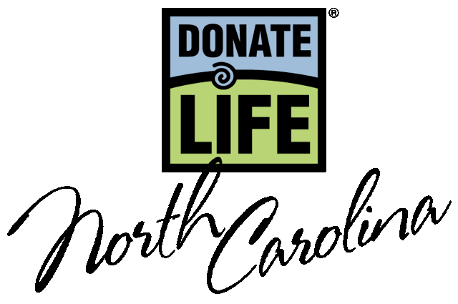

March 2024

Dear Driver Education Instructor,

Thank you for educating your students about the importance of organ, tissue and eye donation. This is a great opportunity to prepare new drivers for their visit to the NC DMV and to inspire them to help save and heal lives.

CAREER AND TECHNICAL EDUCATION ESSENTIAL STANDARDS

The CTE Essential Standards for North Carolina have an objective that covers donation is 9.PCH.1.2--Summarize the procedures for organ donation, local and state resources, and benefits. It's a "Clarifying Objective" that falls under the Essential Standard "Analyze wellness, disease prevention, and recognition of symptoms."

The “Heart Prevails” law (NC General Assembly, Session Law 2007- 538) requires that all applicants for a driver license, permit or ID be offered the opportunity to register as a donor. So, thank you for ensuring your students are prepared for the question!

Feel free to use any of the materials provided to initiate your discussion of donation with the students. And, if you need something else to aid instruction on the topic, please do not hesitate to contact us! Thank you for educating your students about the vital importance of saving and healing lives through organ, tissue and eye donation.

Sincerely,

Tiffianna

Tiffianna Elmore
Teen & DMV Outreach Manager
Donate Life North Carolina
telmore@donatelifenc.org

Donate Life

North Carolina

DonateLifeNC.org

Primary Mailing Address
Deanna Kerrigan
Executive Director
Donate Life North Carolina
PO Box 5536
Cary, NC 27512
919-213-1069
dkerrigan@donatelifenc.org

Chairperson
Matthew Kersten, MS, MBA
Director, Transplant Business
Operations
Atrium Health
704-446-4807
Matthew.kersten@atriumhealth.org

Vice Chair
Carrie Simpkins
Atrium Wake Forest Abdominal
Transplant
Medical Center Blvd.
Winston Salem, NC 27157
336-713-5623 (o)
csimpkin@wakehealth.edu

Secretary
Lora Smitherman
HonorBridge
1430 Westbrook Plaza Drive
Winston-Salem, NC 27103
336-774-4450
Lsmitherman@honorbridge.org

Past Chairperson
Lauren Fieldman, MPH, BSN
Duke Transplant Center
Durham, NC 27710
919-668-3049
lauren.fieldman@duke.edu

